Technical Requirements
of services for development of a software platform for the development of local public services

Procurement No. 302845

Abbreviations and acronyms
Term/abbreviation | Meaning
API | Application Programming Interface – a set of rules and tools enabling interaction between different programs
BPMN | Business Process Model and Notation (graphic notation used for modelling business processes in information systems to make them more efficient and enhance their automation. It allows to build a structured diagram displaying the sequence of business-process stages and their dependencies)
JSON | JavaScript Object Notation - текстовий формат обміну даними, заснований на JavaScript
PPAE | Public Procurement Act of Estonia
Beneficiary | Zhytomyr Regional Military Administration
Demobilzed veterans / veterans | War veterans, persons who made special service to the country, affected participants of the Revolution of Dignity, family members of these persons and family members of fallen (deceased) war veterans, family members of fallen (deceased) defenders of Ukraine
Contractor | Winner of the procurement procedure with who the Parties sign the procurement contract
ESPD | European Single Procurement Document
EDRVV | Unified State Register of War Veterans
Electronic public service  (e-service) | A service provided by state bodies, local self-government bodies, companies, institutions, organisations reporting to them, including administrative services (also provided in the automated mode) provided via information and communication systems in line with an application (request) submitted in electronic form via information and communication systems (including the Unified State Web Portal of Electronic Services) or without such an application (request)
EO | Electronic office
QES/AES | Advanced electronic signature based on the qualified electronic signature certificate or a qualified electronic signature created in accordance with the Law of Ukraine “On Electronic Identification and Electronic Trusted Services”
ASC | Administrative service centre
NPA | Regulations of Ukraine
PA | Public authority
Contracting Authority | e-Governance Academy (in Estonian: E-riigi Akadeemia)
PB | Private business
Platform | Software platform for the development of local public services
Project | Development of digital municipal services for demobilzed veterans in Ukraine
PPRE | Public Procurement Register of Estonia

Procurement of services for the development of a software platform for the development of local public services (hereinafter referred to as the “Platform”) is taking place as part of the international technical assistance project “Development of Digital Municipal Services for Demobilzed Veterans in Ukraine”, funded by EstDev (registration card of the international technical assistance project (program) No. 6089 of 09 July 2025) (hereinafter referred to as the “Project”).

1. Goal and purpose of the Platform
Development of a programming platform for the development of local public services to respond to the urgent need for a fast, user-friendly, and effective access to a broad range of electronic services. This platform must serve as a single entry point, which will significantly facilitate interaction between veterans and local self-government bodies, health-care facilities, educational institutions, and other bodies that are crucial for their successful adaptation to civil life.
The main goal of the Platform is to develop a single digital platform for local public services, in particular, improving the quality of life of demobilzed veterans and their family members through a simpler access to public and social services, reduced bureaucracy, and more effective interaction with relevant public bodies.
The purpose of the Platform is to perform a number of key functions meeting the needs of demobilzed veterans:
- Single entry point for services: veterans must have centralized regional- or local-level access to electronic public services that they can use without having to visit different public bodies via the applicant’s electronic office;
- Online registration and submission of documents: veterans must be able to register for visits to required specialists as well as submit applications and required documents in electronic form;
- Information hub: veterans must receive up-to-date and credible information about legal changes, state support programmes, entitlements, veteran organisations, and other resources;
- Simplified interaction with state bodies: bureaucracy must be reduced through electronic data exchange and automated process for filing applications and receiving responds from authorities;
- Veteran community: it must be possible to establish a community or a forum for experience exchange and mutual support among veterans.
Overall, the Platform for demobilzed veterans must be a reliable, transparent, and user-friendly tool enabling veterans to exercise their rights fast and without impediments, obtain services they are entitled to, and reintegrate into society successfully after their return to civil life. Service providers can use the Platform to inform about their services, manage the service delivery process, monitor service delivery, analyse the needs of their target groups, and improve their processes. It is an investment in the future of our defenders and their families.

2. Composition of the services
The services cover the development of the Platform that includes the following components:
- Module “Management system for electronic public services”;
- EO of the PA providing local services;
- EO of the PB providing local services;
- Client for the service of interaction with the EDRVV via the Trembita data-exchange bus;
- Electronic office of the applicant for obtaining services from a local administration;
- Module for obtaining digital copies and metadata of documents through Diia.Sharing;
- Module of integration with the public portal of a local self-government body or a local state administration;
- Module of integration with the mobile application of a local self-government body or a local state administration;
- Development of 3 local public services for demobilzed veterans.

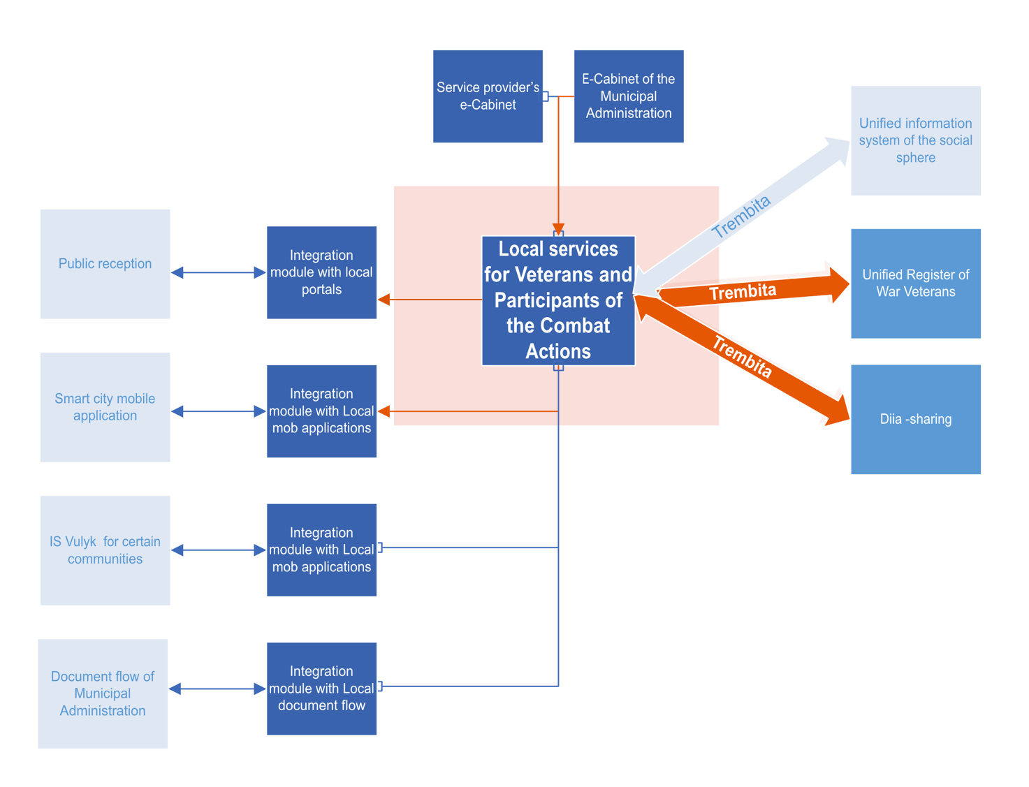

3. Functional requirements

3.1. Module “Management system for electronic public services”

The module must be designed to manage and set up the service delivery processes. Each service must be designed as a separate business process described with the BPMN notation and programmed in the module’s process design tool. This business process consists of logically completed blocks. Each block has the below functionality in line with its respective type:

- Process start and completion;
- Completion of the user form and generation of a document or an application signed with a QES/AES;
- Gateway for logical operations;
- Messaging.

A framework designed specifically for the module is use for the block configuration. The framework is based on JSON along with the list of controls required for services implementation.
The module must have the option and functionality for setting up e-services and e-services for PB.
The module must have a subsystem for logging the actions of users, which includes the time, user ID, operation type, and the network address.
The module must have a subsystem for compiling reporting and statistical information.

3.2. Central directory of municipal services

The central directory of municipal services is a public catalogue with a search system that contains service descriptions as below:

- Order reference (for electronic services);
- Description of the service delivery procedure;
- List of the required documents;
- Service delivery duration;
- User identification procedure (for electronic services);
- Service price and payment procedures;
- References to regulations and other sources;
- Provider’s contact data.

3.3. Applicant’s electronic office for obtaining services from a local administration

The applicant’s EO shall allow a user authorized via Diia.Signature and/or QES/AES and/or Bank.ID to apply for a public local service.
The applicant’s EO shall display a catalogue of services available for the Applicant containing their description, delivery procedure and timelines depending on the Applicant’s status verified through electronic interaction.
The applicant’s EO shall be able to save drafts of submitted applications with the option to continue data entry, view the history of previously submitted application along with their processing status, and, if available for a specific service, the service delivery results.

3.4. EO of a public authority providing local services

The EO of a service provider must automate the work of authorized persons deciding on public service delivery.
The provider’s EO must implement the log of applications and completed service assignments operating along with the search and selection system using specified criteria.
The provider’s EO must be designed to process (including package processing) applications from a multi-channel entry programming interface (electronic office, portal, mobile application) and capture the application source. The processing includes the operation of the interface of the authorized person who examines an application and attached documents as well as enters the official decision (approval or reasoned rejection) along with the time and her/his official data.
The provider’s EO must enable the functioning of the user notification subsystem (e-mail, messengers).
The module shall enable interaction with local information systems via electronic interaction (mainly through the API), including Trembita tools or by sending applications in e-format to the respective document management systems (including via SEV OVV). It shall also be possible to receive applications from other sources (ASC etc.).
The EO of a public authority must enable users to process and enter decisions on proposals concerning the provision of services by private business.

3.5. EO of a private business (PB) providing local services

The EO of a private business must allow representatives of private business entities to send proposals concerning delivery of services to discharged veterans through the Platform. Submitted proposals shall contain descriptions of service delivery procedures and the planned number of provided services for a specific period. Filing a proposal shall be considered as a consent to join the public offer with the obligation to comply with the declared service delivery procedure and service quality. Submitted proposals are examined by the representative of a local authority.
The PB EO shall display the decision of a local authority on the approval of a specific service for being provided on the Platform by a private business.
The Platform shall generate impersonalized service assignments with a unique code (QR and digital code) based on submitted applications and reported surplus capacities of private businesses for service delivery in a specific period.
The PB EO shall display service assignments and allow to set marks confirming the actual service provision as per a specific assignment.

3.6. Client for the service of interaction with the EDRVV via the Trembita data-exchange bus

A Client must be developed for the service of interaction with the EDRVV via the Trembita data-exchange bus. A specification for data exchange with the EDRVV service must be prepared for the client. In addition, a draft contract on information interaction must be prepared.

3.7. Module for obtaining digital copies and metadata of documents through Diia.Sharing

The module must be designed to provide digital copies and metadata of the applicant’s documents when filling in applications in the EO of a local administration.
An authorized User (Applicant) must be able to initiate a request for the digital copies and metadata of a specific document (biometric passports: ID card, travel passport, taxpayer card, certificate of an IDP, driver’s license, vehicle registration certificate, student card, education certificates, veteran card, birth records, name-change records, marriage and divorce records). After the User has provided a confirmation in the Diia mobile application, the System must accept the respective document and data. Based on this, the received data are added to the draft application for a public local service.

3.8. Module of integration with the public portal of a local administration

The module must enable the operation of the unified authorization model of the public portal of a local administration and the EK of a local administration and a provider for service delivery. Integration with the portal must allow to provide consolidated statistical reporting information (dashboard) to be published on the portal.

3.9. Module of integration with the mobile application of a local administration

The module of integration with the mobile application of a local administration must allow to receive the data of an application for a public local service to process them in the EO for local service delivery.

3.10. Development of 3 local public services for demobilzed veterans
The specific services will be determined at the stage of consultation with the Beneficiary.

4. Non-functional requirements

4.1. Applied software requirements
The applied software shall be based on a free software that does not require any licenses for non-commercial use.

4.2. User interface requirements
- The interface must be simple and clear, so users can easily find required information and perform their operations;
- The interface must comply with the official design code;
- The design shall be displayed correctly and function on different gadgets with different screen sizes (adaptivity);
- The interface shall be accessible for users with specials needs;
- The interface design must ensure fast download and efficient operation;
- Users must receive clear feedback on their actions like confirmation of a successful execution or failure messages;
- A user experience analysis shall be conducted prior to prototyping. It must be based on a “user path” description to better understand users’ needs and expectations;
- Interactive prototypes must be created for testing and approval prior to the development start (tools like Figma, Adobe XD, or Sketch must be used);
- Data exchange shall be supported via interaction interfaces, including SEV DEITR (Trembita).
The Platform shall provide tools for steering and distributing user rights concerning access to information, functions, modules.

4.3. Organisational requirements
The following measures are taken by the Parties to ensure the quality of the Services:
The Contracting Authority shall provide the Contractor and/or the Beneficiary with materials that are required for service provision. All pecuniary intellectual property rights to all intellectual property objects and any other intellectual property objects (including all documentation, descriptions, conditions, reports, manuals, or any other written materials) created in full by the Contractor, its employees, or subcontractors shall be transferred for free to the Beneficiary/Recipient, once the Parties have signed respective Acceptance and Transfer Certificates for the Computer Programs under the respective stage. All pecuniary intellectual property rights to all intellectual property objects created in the course of service provision under this Contract belong to the Ukrainian state represented by the Beneficiary/Recipient.

4.4. Integration requirements
Integration with the EDRVV shall be enabled as part of the Platform development.
The Trembita system for electronic interaction between state electronic information resources shall be used as a gateway for information exchange between systems.

4.5. Development prospects and further modernization of the Services
Detailed requirements are specified during the development of the Terms of Reference.
It shall be possible to modernize and scale up the developed Platform with minimum time consumption concerning the following functions:
- Vertical (increase of the computing capacity of the unified platform, access distribution – also for several administrative units) and horizontal (deployment of several platforms in different regions) scalability in terms of workload and performance;
- Hierarchic management of the region’s portals: setup of the portal pages (names, contact data, etc.), distribution of the access rights, administration of users, setup of services, including copying from the central directory along with the entry of required municipality-specific parameters;
- Editing of the “mandatory/non-mandatory” settings and parameters of the fields in electronic forms;
- Add-up of additional automatic checks (including those involving electronic interactions).

4.6. Methodological requirements
The Contractor shall prepare the required documentation for the developed Platform and provide the below technical documents:
- Terms of Reference for the Platform development;
- User manuals for the Platform;
- Administrator manual;
- General installation, setup, backup copying, and data recovery instructions;
- Preliminary testing programme and methodology;
- Protocol of the Platform’s preliminary testing;
- Source codes (coding results) on an optical data carrier.
All documentation shall be prepared and provided in printed form (original) signed with QES as well as in electronic form (copy) in the Microsoft Word format.
All documents shall be made in Ukrainian.

4.7. Information requirements
Information supply shall meet the following requirements:
- Physical and logical data integrity;
- Minimum volume of excessive saved data;
- Standard form of data presentation;
- Credibility and relevance of data.

4.8. Warranty support
The deployed Platform shall have warranty support (correction of errors, etc.) for six months after the signing of the Acceptance and Transfer Certificate for the Platform under the last stage.
The coding services include warranty support for the Platform as below:
- Monitoring of the Platform operation;
- Response to incidents that cause the incorrect operation of the Platform;
- Server configuration, recovery of the Platform operations in case of failures;
- Check of logs and errors in the industrial environment in accordance with the agreed regulations and technical requirements;
- Correction of detected errors and failures in the Platform operation and settings;
- Analysis and correction of errors in the business processes through BPMN 2.0;
- Settings required for the proper functioning of the Platform;
- Hotline for users (phone number, messenger selected by the Beneficiary/Recipient, e-mail).
Information exchange between the Contractor and the other Contract Parties, operational control of the service delivery progress and response to claims take place via GitLab as well as per e-mail.
The response time of the Contractor to received tasks shall not exceed 3 business days and 1 business day for high-priority tasks. The priority level of tasks is determined depending on their relevance for the Platform’s permanent accessibility and operability.

5. Legal references
- Law of Ukraine “On Information”;
- Law of Ukraine “On the National Informatization Programme”;
- Law of Ukraine “On Applications Filed by Citizens”;
- Law of Ukraine “On Access to Public Information”;
- Law of Ukraine “On Information Protection in Information-Communication Systetms”;
- Law of Ukraine “On Personal Data Protection”;
- Law of Ukraine “On Public Electronic Registers”;
- Law of Ukraine “On the Status of War Veterans, Guarantees for Their Social Protection”;
- Law of Ukraine “On the Social and Legal Protection of Military Personnel and Their Family Members” ;
- Law of Ukraine “On Pensions for Persons Discharged from Military Services and Other Selected Persons”;
- Law of Ukraine “On Mandatory General State Pension Insurance”;
- Resolution of the Cabinet of Ministers of Ukraine No. 94 of 16 February 1994 “On the Procedure of Granting Entitlements Specified in the Law of Ukraine “On the Status of War Veterans, Their Social Protection Entitlements””;
- Resolution of the Cabinet of Ministers of Ukraine No. 700 of 14 August 2019 “On the Unified State Register of War Veterans”;
- Resolution of the Cabinet of Ministers of Ukraine No. 740 of 23 September 2015 “On the Approval of the Procedure for Acknowledging the Status of a Family Member of a Fallen (Deceased) Defender of Ukraine”;
- Resolution of the Cabinet of Ministers of Ukraine No. 881 of 02 August 2024 “On Selected Issues Concerning Support for the Activities of Specialists Caring for War Veterans and Persons Discharged from Military Service”;
- Resolution of the Cabinet of Ministers of Ukraine No. 373 of 29 March 2006 “On the Approval of the Rules for Information Protection in Information, Electronic Communication and Information-Communication Systems”;
- Resolution of the Cabinet of Ministers of Ukraine No. 205 of 21 February 2025 “On Selected Issues Concerning the Development, Administration, and Functioning of an Informatization Tool”.

